**[0] 07/26/2016**

**Alan Groff**



Structural Design

(Inside View)

**Vertical corrugation**

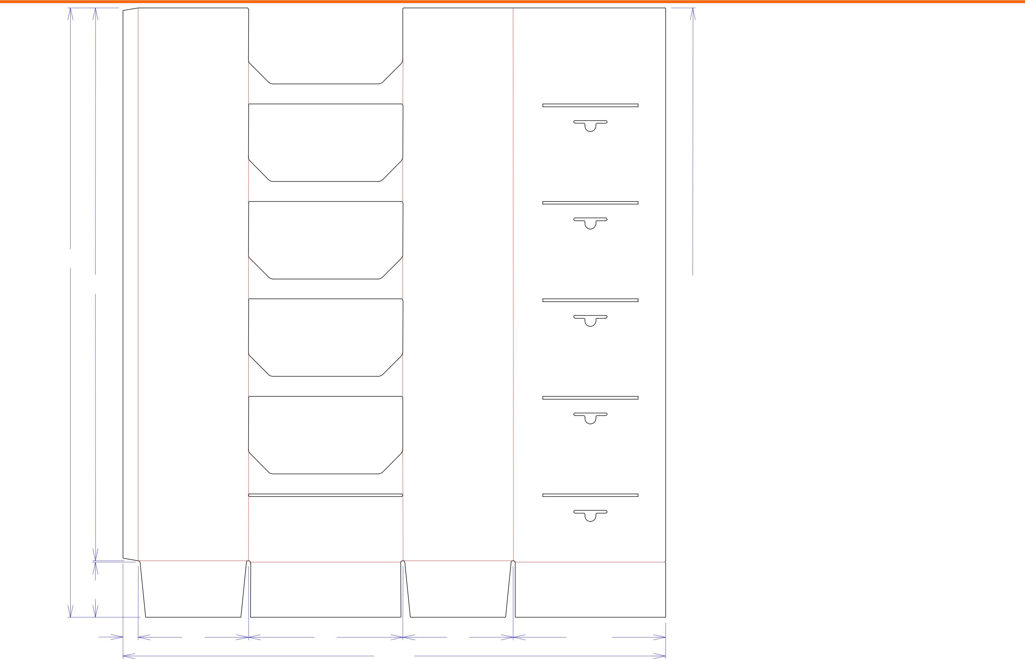

551*/*4

|  |  |
| --- | --- |
| 501*/*8 | 501*/*4 |



|  |  |  |  |  |  |  |  |
| --- | --- | --- | --- | --- | --- | --- | --- |
| 5 |  |  |  |  |  | 5 |  |
| 13*/*8 | 10 | 14 | 493*/*16 | 10 | 1313*/*16 |  |  |
|  |  |  |  |  |  |  |
| Cut | Crease | Crease with Matrix | Cut Crease | Half Knife Cut | Tear Tape | Perforation |  |

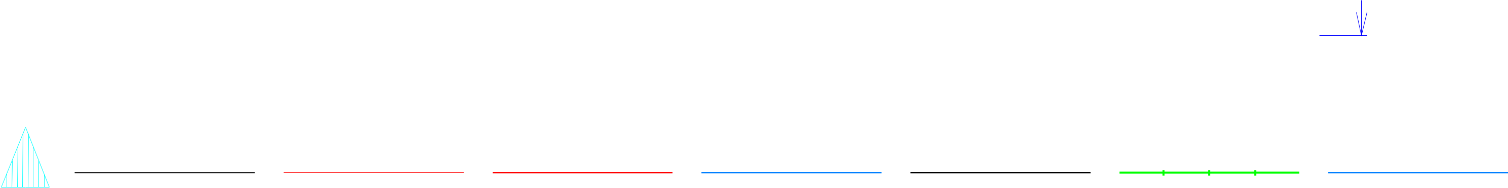

Design#:

**160923-01**

Customer:

**DeMet's Candy**

Description:

**Tower - 40ct 7.5oz Flipz Display**

**SINGLE-OUT DRAWING**

Qty/Unit: **1 Per Display**

Style: **JDC**

Board: **32BCT**

Combination: **37CT - 23M - 35HP**

I.D. : **13+7/8 x 9+7/8 x 50**

Area of Blank - Waste : **15.33 sq. ft.**

Waste on Blank : **18.77%**

Finished Piece Weight: **1.90 lbs./862.91g**

Over-all Blank: **551/4 x 493/16**

Notes:

Revision Info:

Designer:

Designright and Copyright of DS Smith Corrugated Packaging Ltd. This technical Specification is subject to Manufacturing tolerances. Drawing dimensions shown are crease to crease. Date printed: 07/03/2018